Group 1 Final Report

DSC 441

March 20, 2020

Nicole Cummings

Joong Seok Lee

David Guo

James Ahlschwede

## Abstract

The US census is conducted every ten years by counting every single person living in the US. The data collected within this survey is used to determine a number of important events such as how many seats to appoint to the House of Representatives and how federal funding will be disbursed across communities all over the US. Additionally, states can conduct their own census to obtain data for the people living within that state. Due to the vast amount of information provided in census data, for our project, we determined that data analysis within this space would be interesting to explore. It would be a great way to see exactly what information is collected during this survey and use this data to conduct research and learn more about the population of people living within the USA and how demographic variables differ depending on where individuals are located.

For our project, we analyzed 2015 and 2017 census information to answer various questions regarding demographics for all 50 states. We wanted to take a more detailed view on how differences vary across the states including political party preference, income ranges, and job types. We utilized various methods of data analytics to conduct this research including, clustering, regression, and k means. Throughout the course of this paper, we comprised our research questions into four main parts:

1. Predicting election results

During this analysis, one of the goals that we are trying to achieve for this project is predicting results of the 2016 US presidential election by county. Our summarized results were as follows:

* + The logistic model with four predictors turned out to be the best model, with a 0.76 F1 score and 94% accuracy.
  + Some of the results were expected, such as race and gender on political affiliation. Some were surprising, such as construction being the most significant job factor in predicting political affiliation. This is most likely due to the fact by looking at the map, that a higher percentage of construction workers are in rural places that tend to vote Republican.

1. States that are the best and worst for people in different demographic categories

During this analysis the Hispanic, White, and Black cohorts were researched. The following preliminary results were obtained:

* + Hispanic cohort: has the most income opportunity in Washington and least opportunity in New Jersey.
  + Black Cohort: has the most opportunity in Maryland and the least opportunity in Washington. We determined that ethnic and racial impact on income is highly specific to a group within a geography.
  + White Cohort: New Jersey as the best opportunity and Washington has the worst.

1. Illinois Population and Job Demographics

For this section, we reviewed demographics of the top 10 most populated counties in Illinois and the bottom 10 least populated counties in Illinois to see how the various demographic and job variables changed.

During the analysis the following results were obtained:

* Most populous counties:
  + Population and income generally increased from 2015-2017.
  + Poverty and childhood poverty generally decreased from 2015-2017.
* Least populous counties:
  + Population generally decreased from 2015-2017.
  + Income generally increased from 2015-2017.
  + Poverty and childhood poverty generally decreased from 2015-2017.
* For both most and least populated counties, changes in job type and job category were volatile with no clear patterns within the data.

4. Predicting Income from Census Data Results

Within this section, the problem that was analyzed was to see how strong census data may act as predictor of income value. Results from this analysis were obtained and summarized below:

* There was a negative correlation in the variables ‘white’ vs ‘black’ which indicate population exclusiveness.
* For ‘Asian’ and ‘Pacific’ variables, this analysis showed a positive correlation, which means regional similarity of those two ethnicities.

Throughout this paper, we will dive deeper into each of these sections and explain the analysis performed, any outliers we came across, and the results of our data analysis.

## Introduction

Our project is focused on analyzing US census data from the 2015 and 2017. Within this data, there are many variables that we were able to explore, manipulate and extract information from to learn about the different demographics of the people living within the US. Through our research, the overall problem we are attempting to solve is to determine how demographic variables differ depending on where people live, their gender, marital status, and age can affect these demographics. The research questions we focused on to guide on analysis are included below:

1. Identify differences in states based on demographics.

2. Political party preference based on demographics.

3. Predict income of the county based on its demographics.

4. Clustering tracts in different demographic patterns.

5. Changes in demographics over time, which factor changed the most for specific counties?

6. Which states are best/worst for people in different demographic categories in terms of their income? Did it change from 2015-2017?

7. Changes in jobs held within certain counties and any changes that occurred form 2015-2017.

The reason this data analysis was performed was to solve the questions listed above and determine if there are better places to reside and obtain a job versus other areas within the US. Since state borders are arbitrary, we believe that differences will be attributable to local laws and public policy, as well as the diversity of people living between states. We obtained the dataset we are using from Kaggle.com. When we first began exploring with the data, we ran into some issues and noticed that to properly answer our research questions, we would need additional data to add to our current dataset to fully answer questions. Additionally, as we continued our research, other questions arose and we were required to explore other variables and datasets to obtain a complete understanding of the data and our questions.

## Data

The US Census data we utilized for our research was obtained from Kaggle.com. The US Census Bureau collected the data used within this data set. The URL is provided in the references section of this paper. The data includes information for the entire country and includes two data files that have the following information:

* acs2015_census_tract_data.csv: Data for each census tract in the US, including DC and Puerto Rico for 2015.
* acs2015_county_data.csv: Data for each county or county equivalent in the US, including DC and Puerto Rico for 2015.

Additionally, this information is also provided for the census data on the tract and county level from 2017. The datasets have information for the entire country and includes the following variables:

* Census tract id, state, county, total population, men, women, Hispanic, white, black, native, Asian, pacific, citizen, income, income err, income per cap, poverty, child poverty, professional

## Methodology

Within this section, the methodology for each section is broken into four parts which will go into further analysis on what research question was answered, what methods were used, and the results of the analysis.

**Part 1: States that are the best and worst for people in different demographic categories**

For this section, we started exploring the relationship between demographic class membership and income at the state level with linear regressions on all the classes. What we generally found was data that couldn’t be compared across states, but rather spoke to the distribution of diversity between rural and urban areas. In Tennessee we found rural areas had a larger white population and lower incomes, and urban areas had a smaller white population and higher incomes.

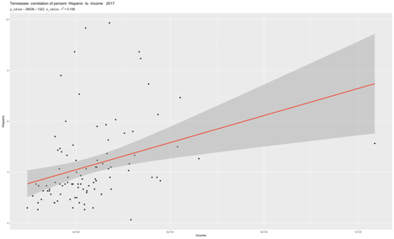

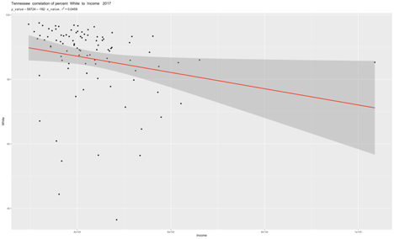

What we were interested in finding was the impact of living in a state on income for different groups, if all else was equal. Various methods were considered for creating peer groups for comparison – one common method we discovered was the hand selection of border census tracts to do a comparison between two arbitrarily bounded areas, but this was logistically challenging. We decided to do a k-means clustering into the maximum number of groups (which turned out to be 10) using all of the fields that weren’t part of the area’s demographics ( "Hispanic", "White", "Black", "Native", "Asian", "Pacific") or identity ("State","County", "CountyId).

Each area has a similar total population number, but in our dataset, we now had a mix of percentages written as decimals less than 1 and values that were in the thousands. We brought the numbers into the same order of magnitude by multiplying all the percentages by the total population for the area.

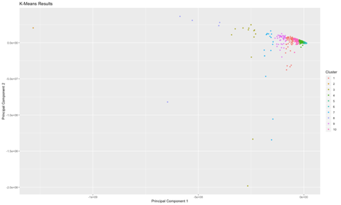

Unfortunately, of our 10 clusters, only 1 of them had a sufficient population for our comparison, cluster 6.

|  |  |
| --- | --- |
| Cluster ID | Number of data points |
| 1 | 60 |
| 2 | 1 |
| 3 | 13 |
| 4 | 226 |
| 5 | 535 |
| 6 | 2214 |
| 7 | 16 |
| 8 | 5 |
| 9 | 45 |
| 10 | 104 |

To generate our favorability score we ran the same linear regressions as before but using the smaller sets. To create final scores and to make the values easier to compare we normalized all the coefficients within a demographic to a value between 0 and 100, and charted the results.

**Results and Conclusion**

We found the following best and worst states for income for the following demographic groups:

|  |  |  |
| --- | --- | --- |
| Group | Best | Worst |
| Men | Massachusetts | Michigan |
| Women | Massachusetts | Michigan |
| White | New Jersey | Washington |
| Black | Maryland | Washington |
| Hispanic | Washington | New Jersey |

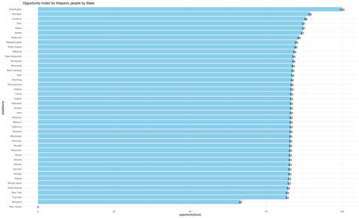

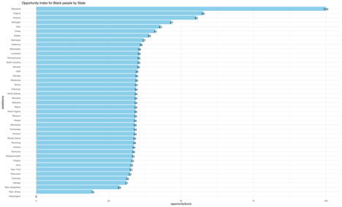

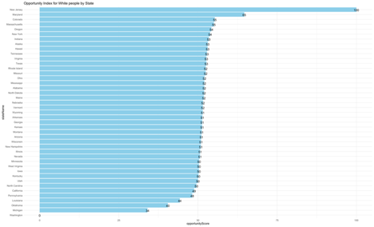

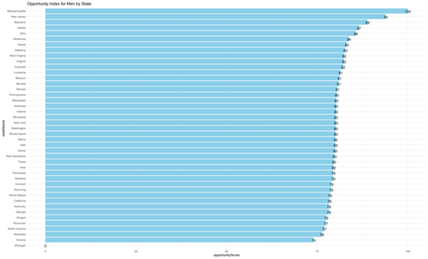

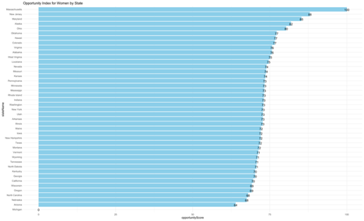

**Part 2: Predicting Election Results**

Another aspect we are interested in exploring is looking into the relationships between the variables in our dataset with the voting results in the 2016 election. We tried to look for variables that were significant in determining who voted for what party in the election. Since the census data didn’t have political information, we found data online that showed 2016 US election results by county, and then we joined both datasets based on county fips code.

Before creating a model, we removed certain variables that we thought weren’t useful in the model such as the margin for error in the income, as well as transforming some other variables such as taking the logarithm of the population to create the “logpop” variable, and creating some new variables, such as dividing the amount of men by the total population to get the percentage of men in this county.

We plotted some of the data using the usmaps package to see how certain variables have differences between counties, the differences could translate to political differences as well, so we made scatterplots to illustrate that relationship.

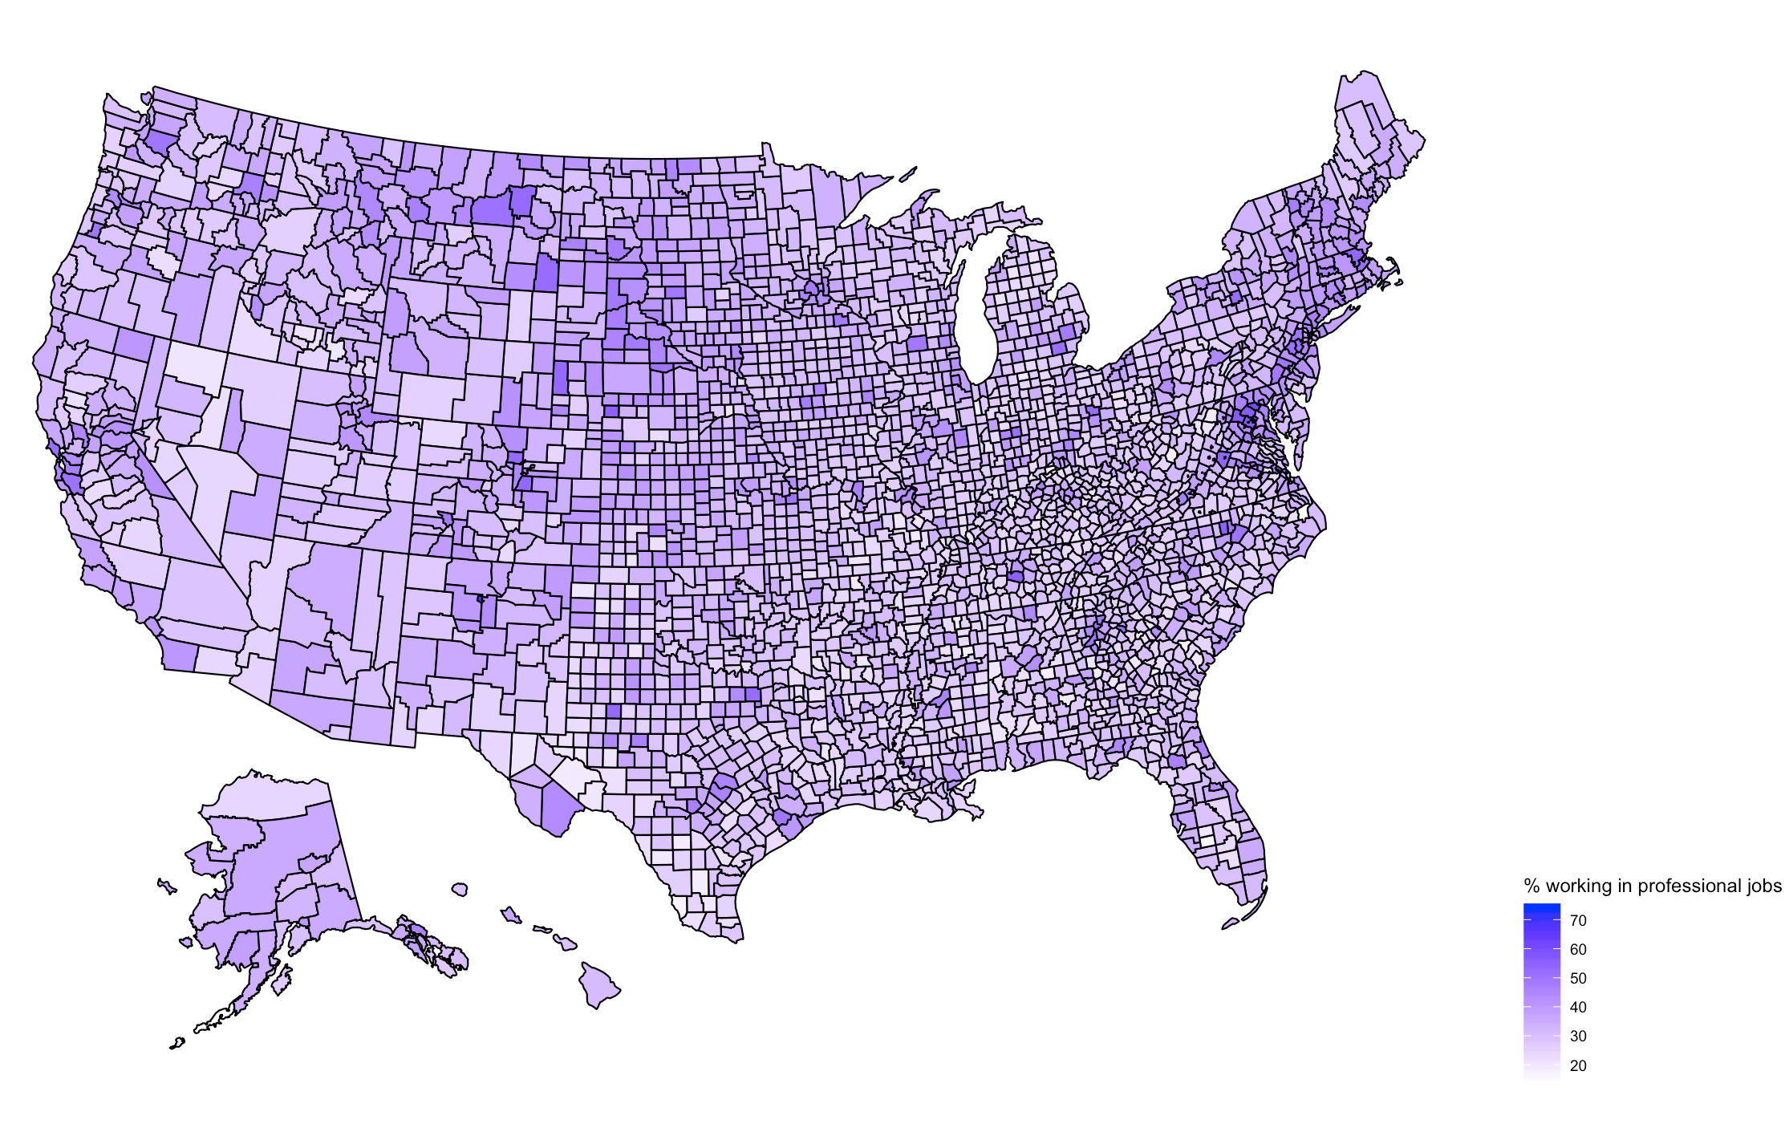

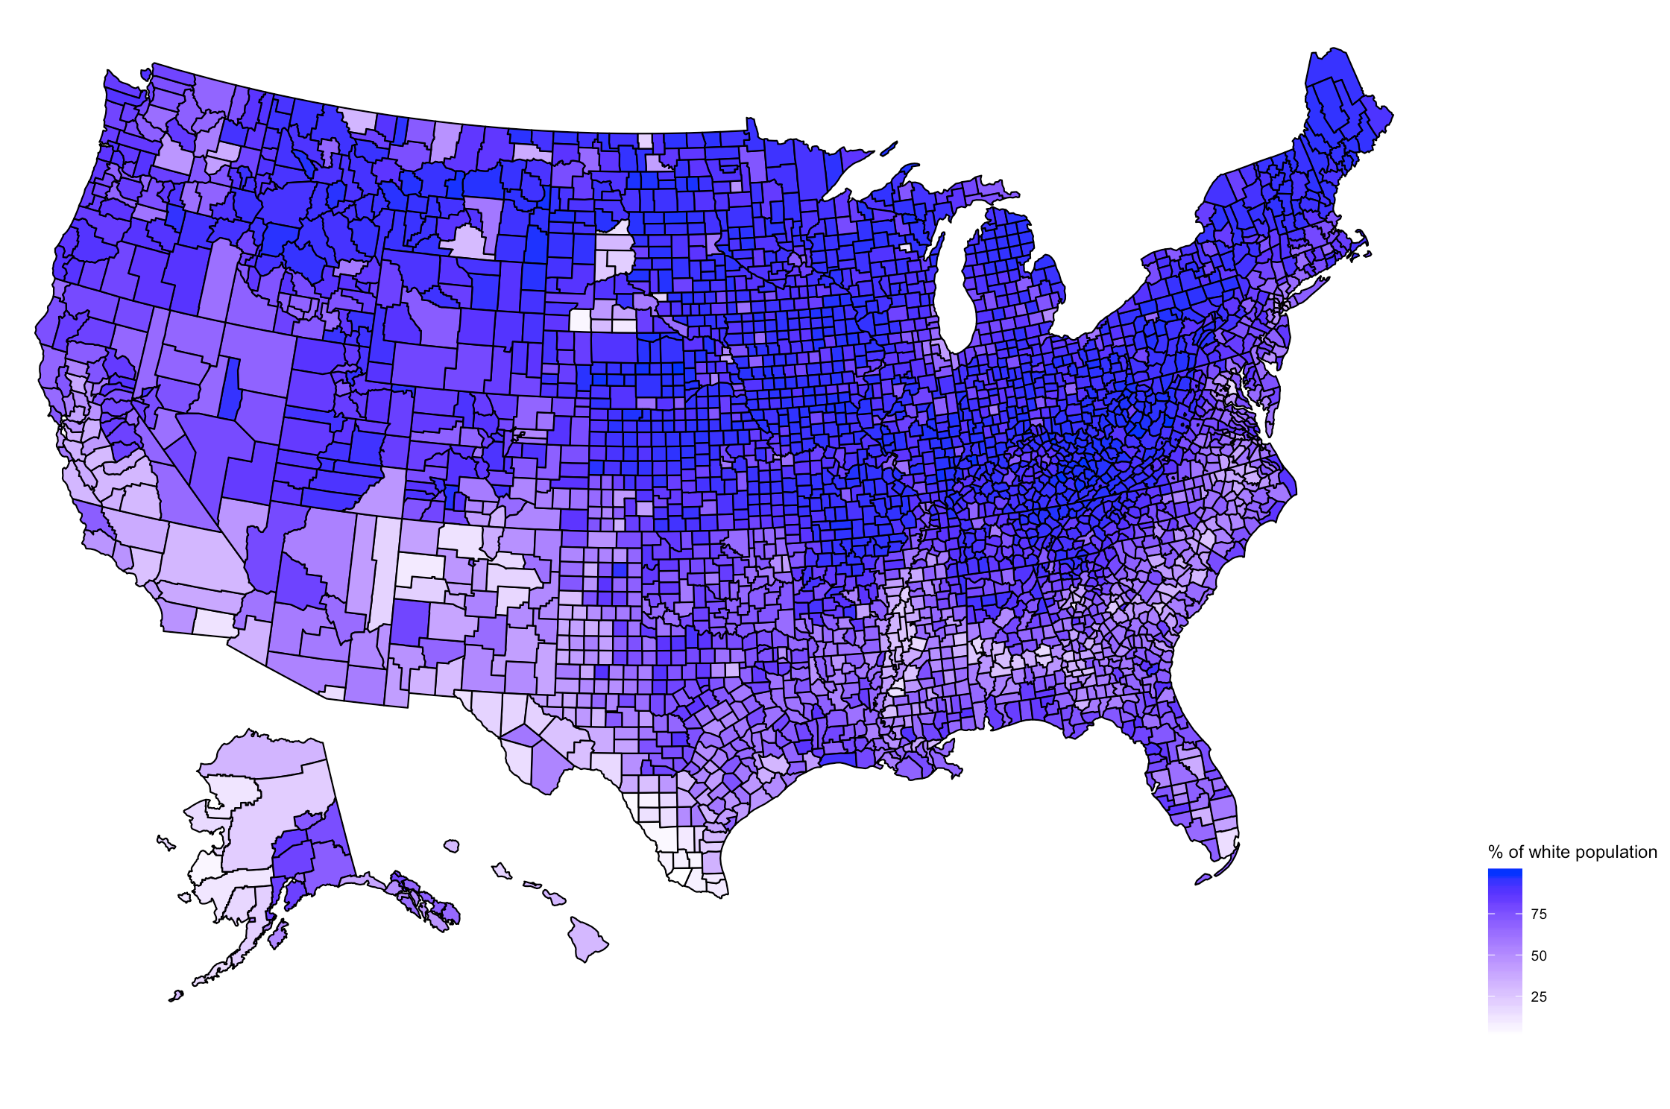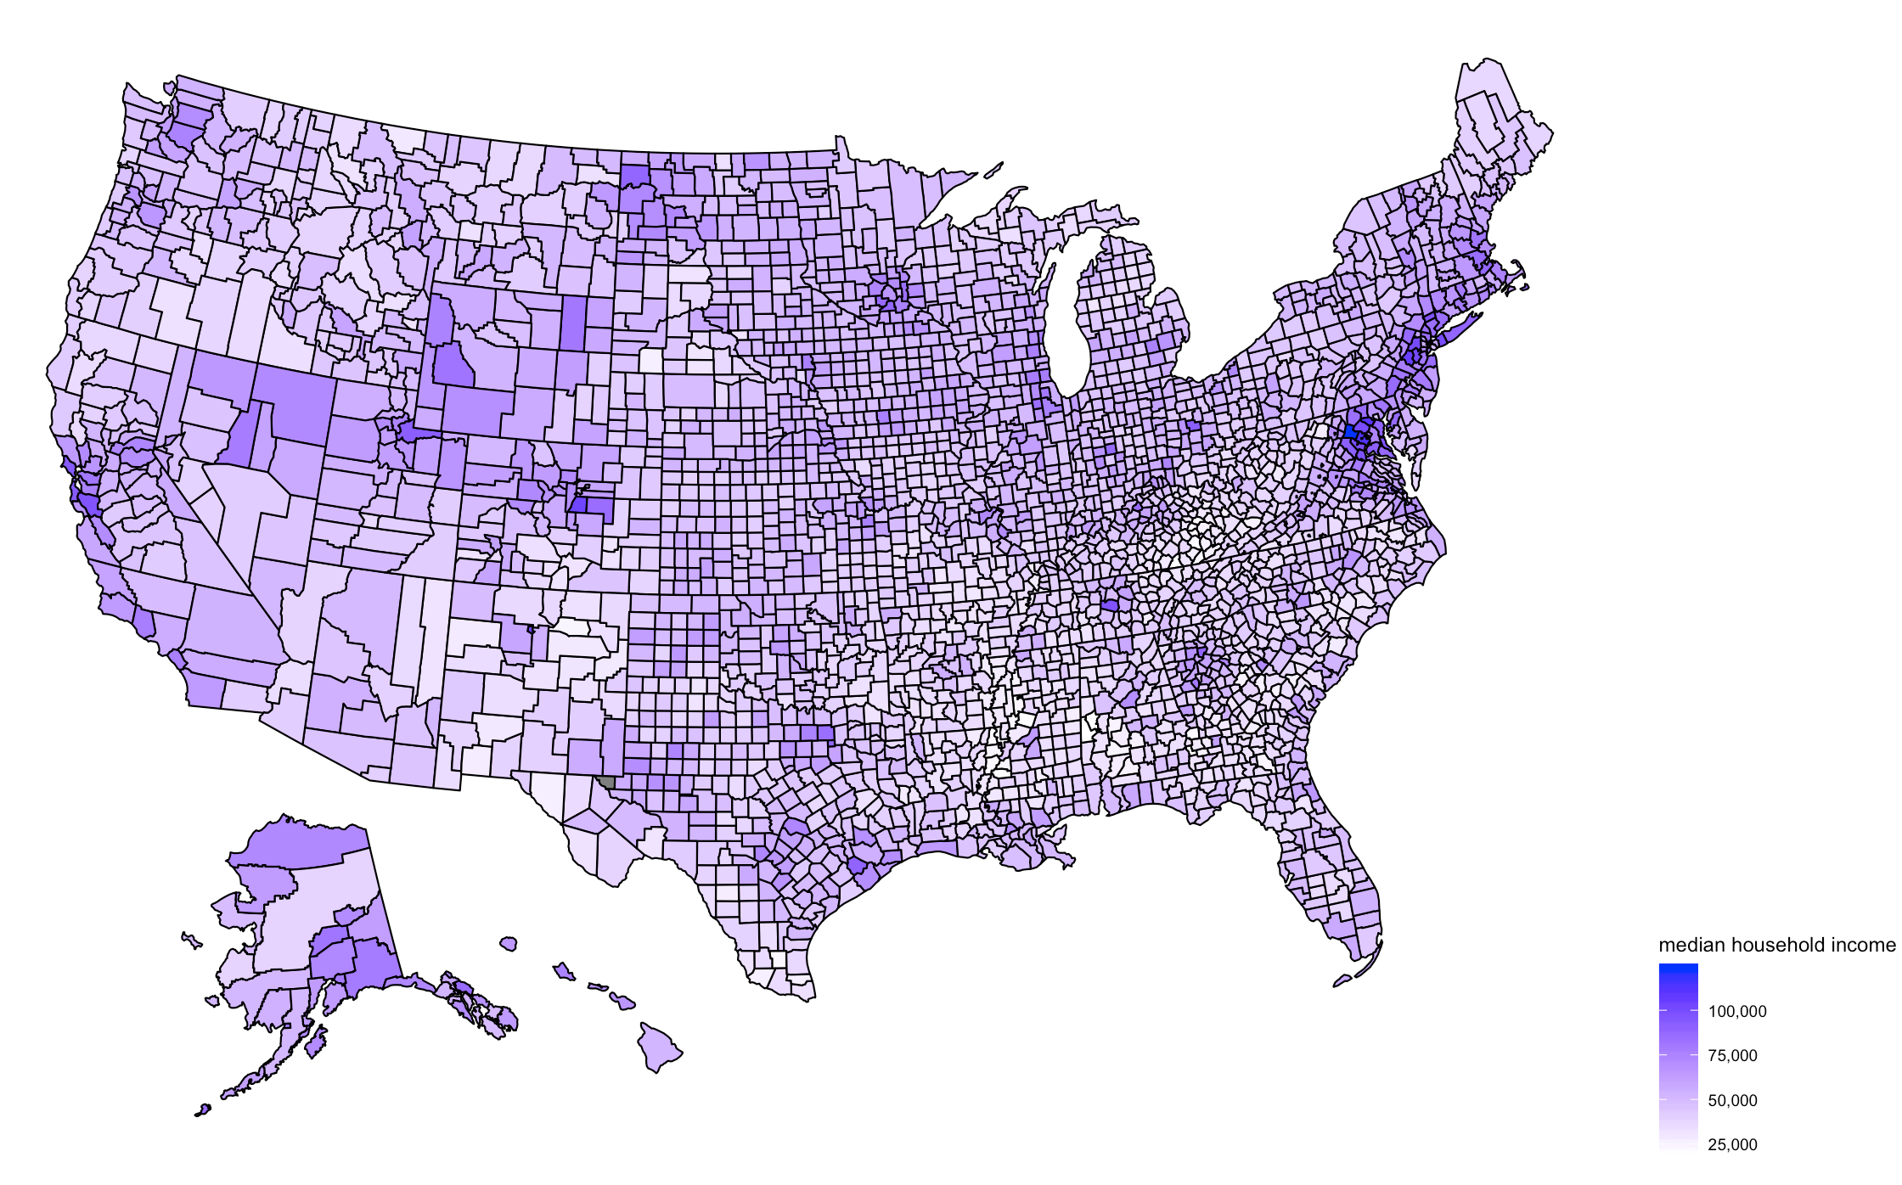

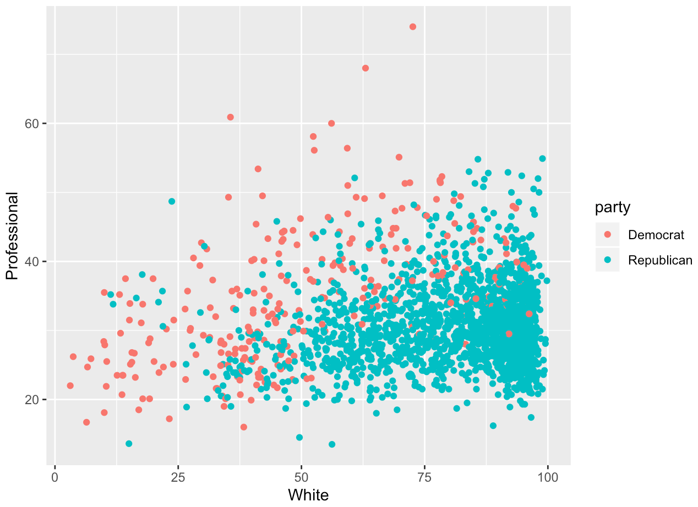

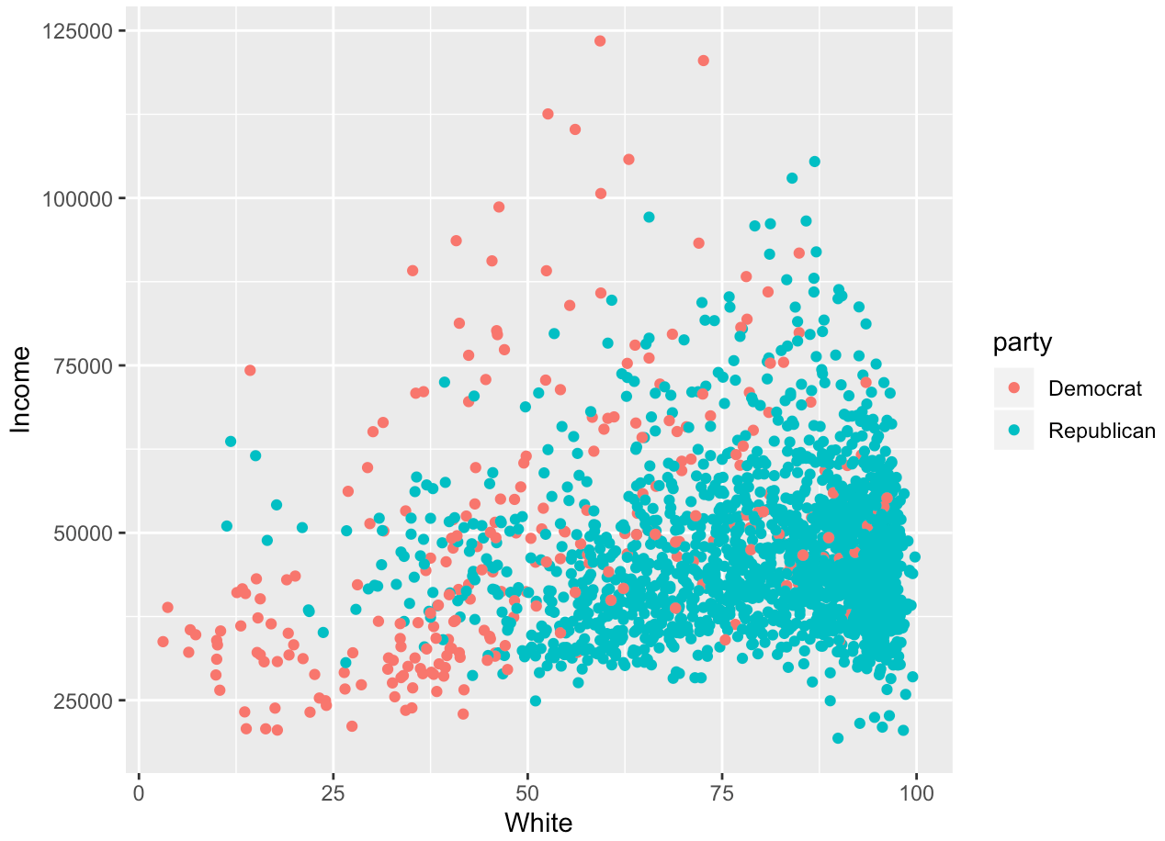

There are noticeable differences between counties looking at the maps plots in regards to variables like race and employment. The scatter plot of percentage of white population and percentage of people working in professional jobs plotted by political parties shows some clustering, where the counties with larger white populations and lower percentage of professional workers mostly vote Republican. The plot of median household income and percentage of white population shows similar results as well.

We also split the data into test and training data and used the models in the training data to predict the results in the testing data. We created two columns based upon the voting results, where one column was a integer column where a county that had greater than 50% votes for Democrat could have a value of 1, while county that had less than 50% votes for Democrat could have a value of 0, and another character column, a county that had greater than 50% votes for Democrat would have a value of “Democrat”, while county that had less than 50% votes for Democrat would have a value of “Republican”.

The first model we used was a decision tree model. We initially created a decision tree with all the variables that were left after removing and transforming the data from previously. After creating the tree, we removed all of the variables that weren’t included in the tree to avoid overfitting. This left us with 6 variables in the tree. (White, Construction, Transit, Income, Percentmen, PrivateWork (the income of the county, and the percentage of people who are white, men, take public transit, and work in construction and the private sector, respectively.) From the model, it looks like the data first splits in on the percentage of white population in the county, in which 11% of the counties with a white population of <50% voted Republican, so it seems like it's the most important variable. The second split was on construction and transit, the third split was on percentmen (on construction), income (on construction), and construction (on transit), and the fourth split was on privatework (on percentmen).

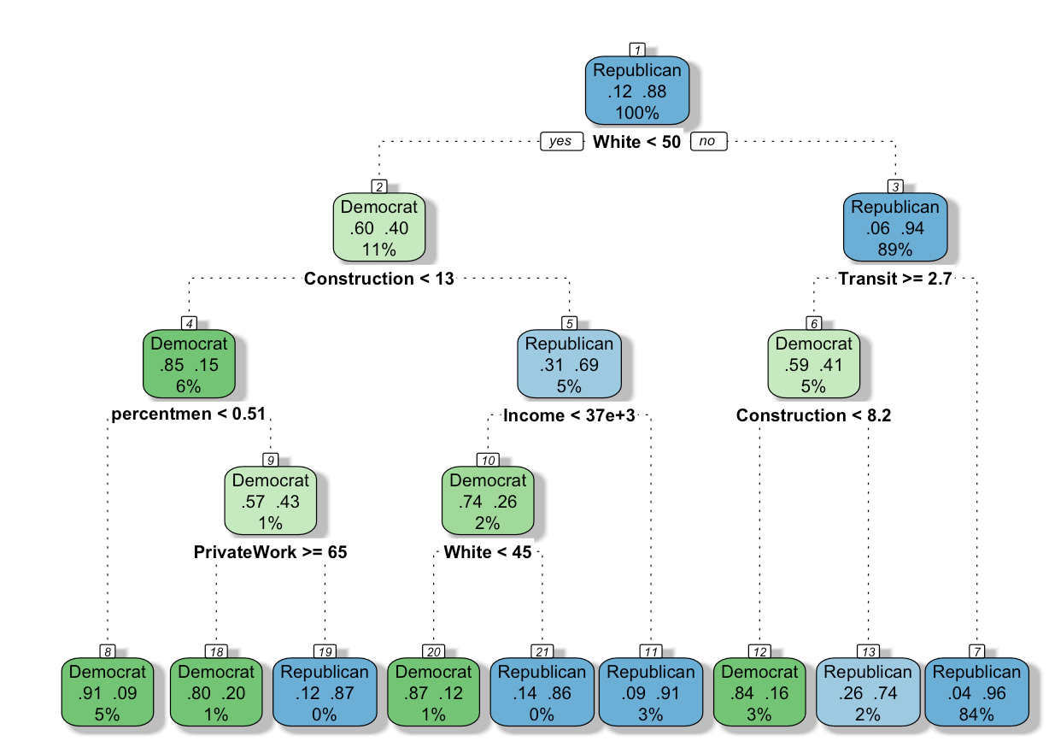

We used the decision tree model that was obtained on the training set with 6 variables to predict on the testing set. We created a confusion matrix with Democrat as the positive value, and we got an accuracy of 0.931, precision of 0.829, recall of 0.667, and F1 score of 0.739.

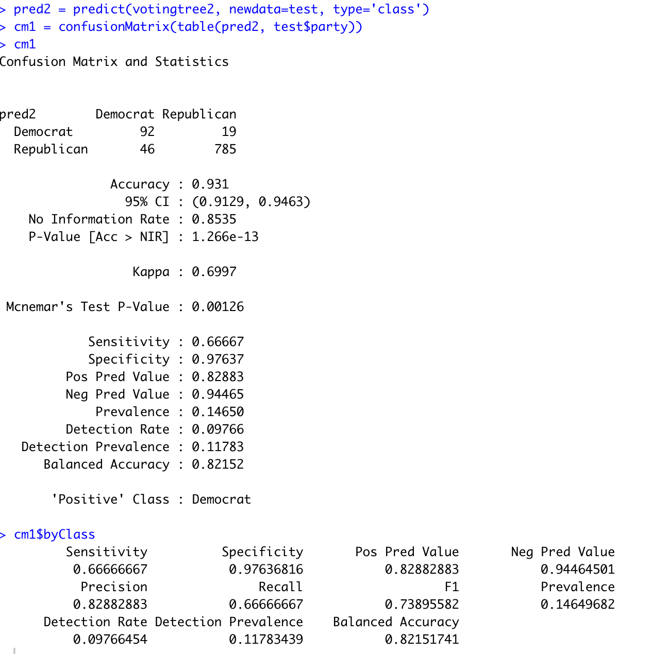

The second model we used for predicting election results was a logistic regression model. We also used logistic regression on the 6 variables that we used for the decision tree and Naive Bayes model.

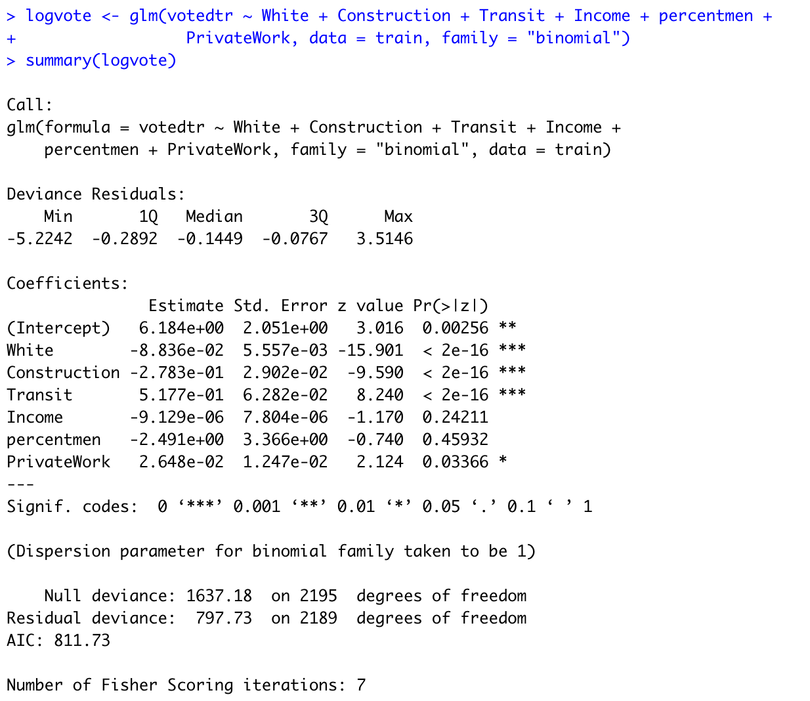

From the summary of the model, we can see that two variables, income and percentmen, were not significant, under an alpha of 0.05, so I removed them from the model and created a new model.

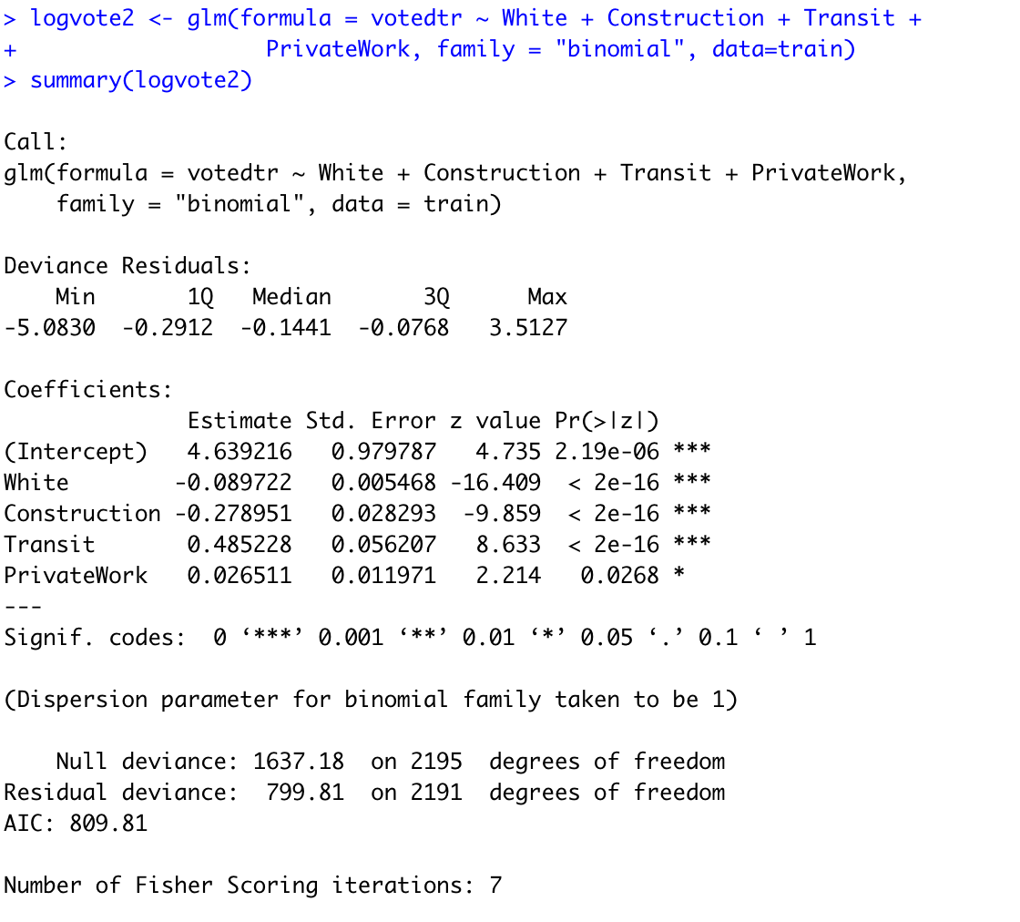

We saw that two variables weren’t significant under an alpha of 0.05 in my model (PercentMen and Income), so we removed them from the model to create a new model. The second model had White, Construction, Transit, and Privatework as all significant variables This model had all variables that were significant under an alpha of 0.05. It looks like for the model, for every increase in percentage of the White population, the log odds of the county voting Democrat decrease by -0.09, for every increase in percentage of the population working in construction, the log odds of the county voting Democrat decrease by -0.27, for every increase in percentage of the population taking public transit, the log odds of the county voting Democrat increase by 0.49, and for every increase in percentage of the population working in the private sector, the log odds of the county voting Democrat increase by 0.026.

We also used the logistic regression model to predict on the training set, and this logistic regression model turned out to have better results, with an accuracy of 0.94, precision of 0.927, recall of 0.644, and F1 of 0.76

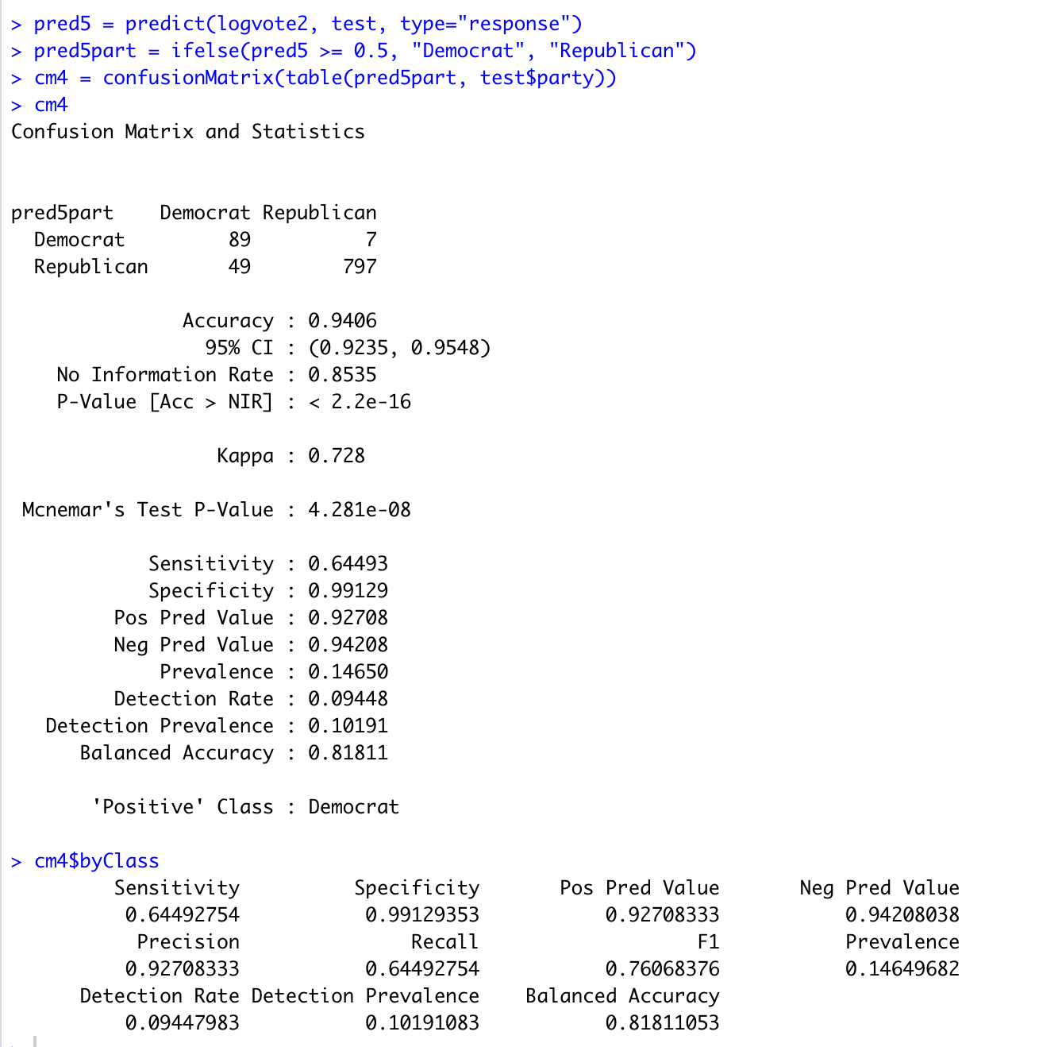

**Results and Conclusion**

Looking at the two models, it looks like the logistic model with four predictors turned out to be the better model, with a 0.76 F1 score and 94% accuracy. Some of the results were expected, such as the effect of race and gender on political affiliation, but some were surprising, as I didn’t think about construction being the most significant job factor in predicting political affiliation. I think that in regards to construction workers and political leanings, it’s not necessarily that construction workers are more likely to vote Republican, but rather looking at a map of percentage of construction workers by state, that a higher percentage of construction workers are in rural places that tend to vote Republican.

If I had more time, I could try to do some variable selection techniques, and look for multicollinearity on the variables. Since this data had almost all continuous variables, I wasn’t able to run Naive Bayes on the data. I could learn more about Gaussian Naive Bayes and run it on the data.

**Part 3: Predicting Income from Census Data Results**

The census dataset has income data from the median value of county or tract population. This problem we came across is to see how strong other census data may act as predictor of income value. These explanatory variables include demographic, commute type and occupation information. The response variable (income) is numeric continuous value, where linear regression analysis works well. Data preparation is performed such as feature selection, and partitioning dataset into training and test sets. I could have used a cross-validation method to achieve unbiased analysis, but for simplicity reasons, I’ve split observations in two sets with predetermined ratio (training:90%, test:10%) from randomly selected data points.

I started examining the data to find correlation between independent variables. First step I took was visualizing the correlation from every pairwise combination of variables. Using R’s plot function, it was a little tricky at first due to the overall size of variables and adjusting the plotted area was not working smoothly.

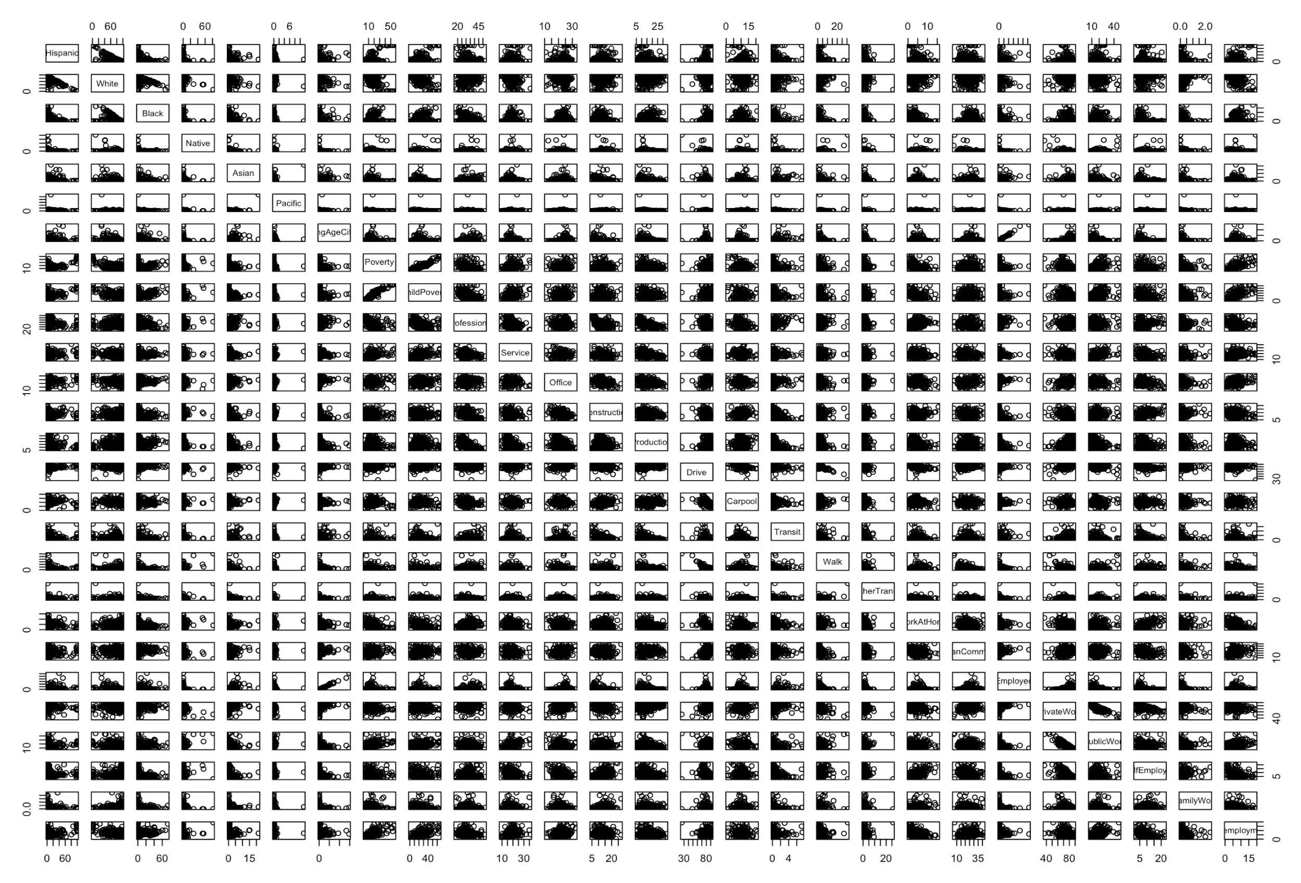

By observing the results, I couldn’t find a strong correlation plot pattern, in a positive or negative way. This tells me I would not worry too much about multicollinearity effects. Then, I’ve gone through with obtaining an actual correlation score by using R’s cor function.

Some notable correlations are found. Negative correlation in variable ‘white’ vs ‘black’ found, indicating population exclusiveness. ‘Asian’ and ‘Pacific’ show positive correlation, which means regional similarity of those two ethnicities. A contrast is shown for some variables, which are easily understood. Such as ‘Drive’ vs. ‘Walk’, ‘Self employed’ vs. ‘Work at home’, or ‘Private work’ vs. ‘Public work’, these commute types and job types are exclusive to each other.

There are some more remarkable correlations in commute types. Later, I performed minimal engineering by removing correlated variables by using lasso technique. For additional data preparation, I removed ‘Pacific’ and ‘ChildPoverty’ from above correlation analysis and also removed ‘Poverty’ and ‘Unemployed’ variables, since they are apparent direct predictors.

The initial model was built by using R’s lm function incorporating all the variables except those deleted and response variables. Here’s the summary of my initial model:

lm(formula = Income ~ ., data = acs17_train)

Residuals:

Min 1Q Median 3Q Max

-34324 -5314 -493 4809 51583

Coefficients:

Estimate Std. Error t value Pr(>|t|)

(Intercept) 7.420e+05 4.498e+05 1.650 0.099090 .

Hispanic -3.521e+02 9.918e+01 -3.550 0.000392 ***

White -2.463e+02 1.011e+02 -2.438 0.014842 *

Black -4.128e+02 1.004e+02 -4.111 4.05e-05 ***

Native -2.431e+02 1.089e+02 -2.233 0.025613 *

Asian 8.875e+02 1.578e+02 5.624 2.04e-08 ***

Professional 7.682e+00 2.513e+03 0.003 0.997562

Service -1.391e+03 2.512e+03 -0.554 0.579963

Office -9.631e+02 2.512e+03 -0.383 0.701392

Construction -5.164e+02 2.512e+03 -0.206 0.837165

Production -1.105e+03 2.512e+03 -0.440 0.660173

Drive -3.823e+03 2.386e+03 -1.603 0.109116

Carpool -3.695e+03 2.388e+03 -1.547 0.121889

Transit -3.805e+03 2.386e+03 -1.595 0.110818

Walk -3.688e+03 2.385e+03 -1.547 0.122085

OtherTransp -3.746e+03 2.388e+03 -1.568 0.116890

WorkAtHome -3.260e+03 2.386e+03 -1.366 0.171918

MeanCommute 1.905e+02 3.412e+01 5.582 2.60e-08 ***

Employed -9.263e-04 1.252e-03 -0.740 0.459590

PrivateWork -2.083e+03 2.865e+03 -0.727 0.467270

PublicWork -2.576e+03 2.865e+03 -0.899 0.368763

SelfEmployed -2.956e+03 2.865e+03 -1.032 0.302149

FamilyWork -4.365e+03 2.881e+03 -1.515 0.129766

---

Signif. codes: 0 ‘***’ 0.001 ‘**’ 0.01 ‘*’ 0.05 ‘.’ 0.1 ‘ ’ 1

Residual standard error: 8828 on 2874 degrees of freedom

Multiple R-squared: 0.5894, Adjusted R-squared: **0.5863**

F-statistic: 187.5 on 22 and 2874 DF, p-value: < 2.2e-16

The analysis on the summary log indicates that the F-testing result shows significance, which means at least one or more beta estimations in the model is non-zero and significant. The adjusted R-squared value tells me my model has a good fit with training values, I predict this is because not much correlation exists between independent variables. By looking at those significant p-test results of some variables, the racial data seems to be the strong predictors. One thing noticed is that the ‘mean commute time’ variable is a considerably strong influencer of income. This is somewhat not understandable, as it possibly indicates people with higher incomes live farther from their workplace.

During correlation analysis earlier, I’ve noticed that the commute type variables show some correlation to each other, therefore I’ve performed additional feature selection process as the next steps. I used Lasso regression technique.

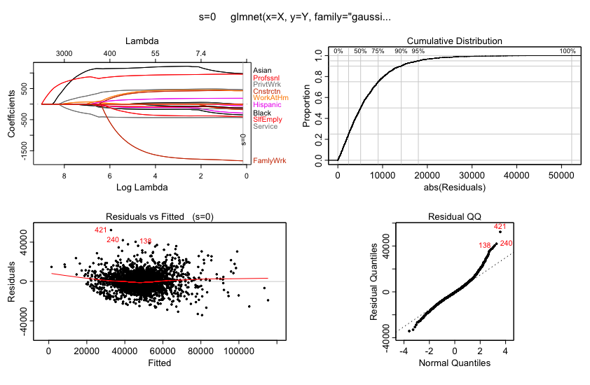

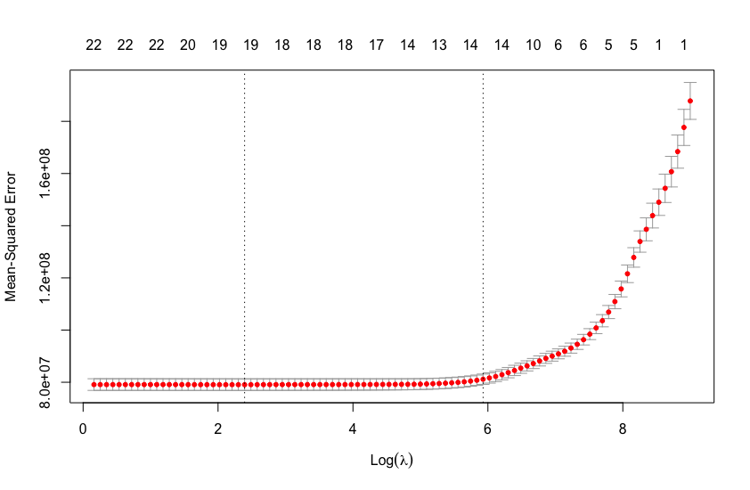

In the Lasso analysis shown above, I confirmed good normality in residual analysis and the distribution is also not showing an apparent pattern with optimal lambda value. I could see the non-significant variables by listing Lasso coefficients results.

(Intercept) -493.17923

Hispanic -72.70034

White 20.80377

Black -128.23680

Native .

Asian 1143.59072

Professional 874.23377

Service -419.69388

Office .

Construction 189.57431

Production -126.99449

Drive -65.42038

Carpool .

Transit .

Walk .

OtherTransp .

WorkAtHome 233.57710

MeanCommute 107.07402

Employed .

PrivateWork 413.93491

PublicWork .

SelfEmployed -136.74725

FamilyWork -667.78154

The results suggested me to further remove ‘Native’, ‘Office’, ‘Carpool’, ‘Transit’, ‘Walk’, ‘OtherTransp’, ‘Employed’, ‘PublicWork’ variables from the model. The final model is built with selected variables as shown below:

Residuals:

Min 1Q Median 3Q Max

-33560 -5326 -479 4834 53389

Coefficients:

Estimate Std. Error t value Pr(>|t|)

(Intercept) -3798.02 6412.35 -0.592 0.55370

Hispanic -139.14 24.67 -5.639 1.87e-08 ***

White -26.60 25.10 -1.060 0.28928

Black -198.40 25.73 -7.710 1.72e-14 ***

Asian 1152.37 79.83 14.435 < 2e-16 ***

Professional 942.73 68.31 13.800 < 2e-16 ***

Service -434.04 76.84 -5.648 1.78e-08 ***

Construction 450.75 68.20 6.610 4.57e-11 ***

Production -153.72 61.12 -2.515 0.01196 *

Drive -88.30 29.20 -3.024 0.00252 **

WorkAtHome 466.83 87.14 5.357 9.12e-08 ***

MeanCommute 169.97 31.51 5.393 7.47e-08 ***

PrivateWork 479.52 35.80 13.395 < 2e-16 ***

SelfEmployed -382.49 72.70 -5.261 1.54e-07 ***

FamilyWork -1776.67 400.53 -4.436 9.51e-06 ***

---

Signif. codes: 0 ‘***’ 0.001 ‘**’ 0.01 ‘*’ 0.05 ‘.’ 0.1 ‘ ’ 1

Residual standard error: 8834 on 2882 degrees of freedom

Multiple R-squared: 0.5876, Adjusted R-squared: **0.5856**

F-statistic: 293.4 on 14 and 2882 DF, p-value: < 2.2e-16

The adjusted R-square value is slightly lower than the initial one, but it’s still a good one to fit, since many variables were removed, which normally pulls down the value. The decrease was minimal, which may indicate the selected variables are strong predictors. Also, most of the variables show significance in p-test.

I tested my model with a test set. Prediction performed with test set shows good performance of the model. I plotted the predicted value vs. actual value as shown below, its correlation score was 0.82.

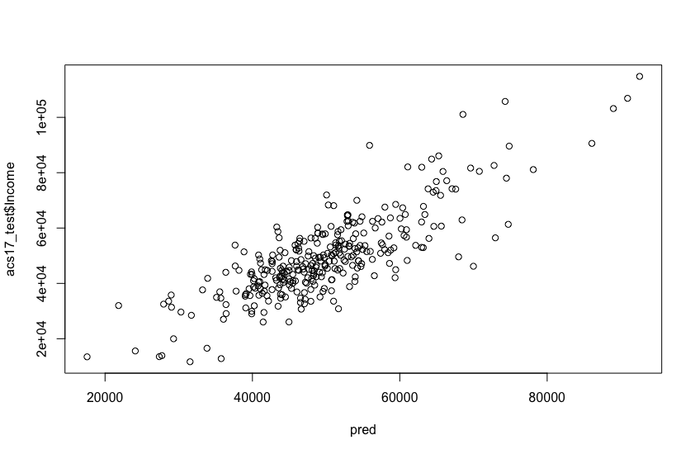

Another problem I was working on was clustering census data into any groups of similar patterns. The initial goal was to achieve clustering in an artificially selected pattern that the model suggests. Soon, I realized the dataset and the scope of the class is not appropriate for the initial goal. Later, I experimented only with racial data to find groups of similar patterns.

The k-means algorithm was used for clustering data over demographic variables. Data preparation introduced a few ad hoc steps of cleanup. Census data had no fips information which can be joined with usmap package data where geographic data of each county is provided. In order to mutate the fips variable in the census dataset, usmaps ‘fips’ function was used. Even though my census dataset was 2017, there were some counties reported invalid or missing from the fips function. I had to remove those manually and further removed Puerto Rico as well. Lastly, I also removed one datapoint where ChildPoverty has N/A value.

As the next step, I selected only racial variables and removed factor variables which are not working with k-means algorithm. I ran k-means with 6 clusters. The result was plotted as shown below.

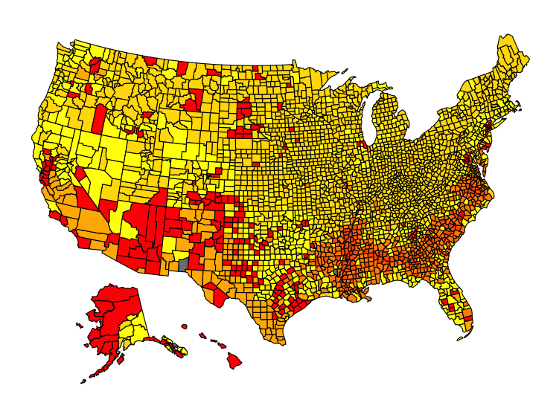

The 6 of color codes range from yellow to red color, where same color-coded counties are having similar racial proportion.

**Part 4: Illinois Population & Job Demographics**

For the first portion of this analysis, Illinois population demographics were explored. We looked at the demographics of the top 10 most populated counties in Illinois and the bottom 10 least populated counties in Illinois to see how the specific variables changed from 2015 – 2017. The variables we observed were total population, population of men and women, income, poverty and child poverty. We then determined what the top 10 most populated counties in Illinois were by filtering the data based on population size. The following counties were determined to be the most populated counties in 2015 and 2017: Cook, DuPage, Lake, Will, Kane, McHenry, Winnebago, Madison, St. Clair and Champaign.

To begin, we wanted to see what the change in population would be for 2015 - 2017. Typically, areas increase in population over time. I wanted to see if this was the same instance for these identified counties. For this portion of the analysis, we obtained the population from the top 10 most populated counties from 2015 and 2017. Then we analyzed the data to ensure the counties that were within the top 10 in 2015 were still the same counties in the top 10 in 2017, which they were the same. Next, we compiled the data to see if there were any changes from 2015 – 2017. From the data, the counties that increased in population were Cook, DuPage, Lake, Will, Kane, McHenry and Champaign. While in Winnebago, Madison and St. Claire, the overall population decreased from 2015 - 2017.

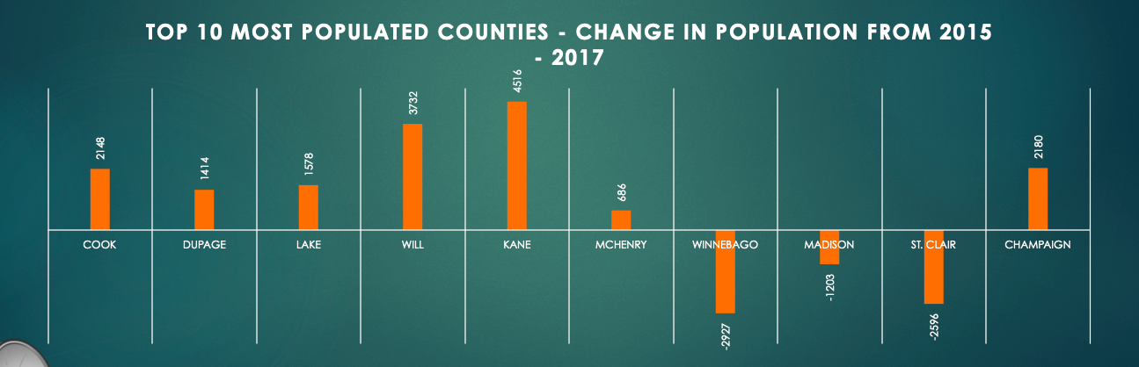

Then we decided to dive even further. We were curious to see if the population between men and women changed over this timeframe as well. The results indicate that the population of men drastically increased in all counties across the board. While the women population decreased in all counties except Champaign. We found this very interesting and wondered why it was not proportionate among men and women. 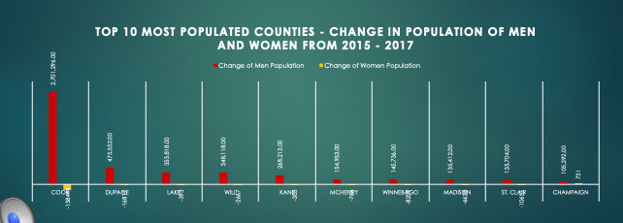

Next, we analyzed the data to see if income has increased throughout this timeframe and if poverty and childhood poverty levels increased or decreased. All counties experienced an increase in income from 2015-2017 which is a great observation. This means within all counties, individuals are increasing their overall income each year.

The next observation was to see if there were any changes in poverty and childhood poverty within these counties. The results were there was a decrease in poverty and childhood poverty from 2015-2017 for all listed counties except Madison. Madison experienced an increase in both poverty and childhood poverty.

Then, we performed analysis to determine the bottom least populated counties within Illinois. This was performed by sorting the counties from lowest population to highest population for both 2015 and 2017. Here, we experienced a difference of counties from 2015 – 2017 with some counties increasing rank and others falling off the chart. Because of this, for the subsequent slides, we will only use the top 5 counties that did not change to perform our analysis. The top five counties include Hardin, Pope, Calhoun, Scott, and Gallatin counties.

During the population analysis, Hardin, Calhoun, Scott, and Gallatin counties all experienced decreases in population from 2015 – 2017. Pope county is the only county that experienced an increase of population. 

Then, the population of men vs. women was performed. There was a drastic change with the population of men and women within these counties. All counties experience a decrease of women and men in the population with the exception of pope county. This county had an increase of male population from 2015 – 2017.

Income was analyzed for the bottom 5 least populated counties next. All counties experienced an increase of income with the exception of Calhoun county. Calhoun county had a decrease in income from 2015 - 2017.

Regarding changes in poverty and childhood poverty, Hardin and Pope counties experienced decreases of both types of poverty. Calhoun and Scott counties had an increase of poverty and a decrease of childhood poverty, while Gallatin county had an increase of both types of poverty.

For the second portion of this analysis, Illinois job demographics were explored. We looked at the demographics of the top 10 most populated counties in Illinois and the bottom 5 least populated counties in Illinois to see how the specific variables changed from 2015 – 2017. We looked at two categories: job category and job type. Job category had the following variables: professional, service, office, construction and production. Job type had the following variables: private work, family work, public work, unemployment, and self-employed.

For the top 10 most populated counties there was a quite a difference within changes of job category. The most popular category was service jobs with increases in every county for this variable. The other variable that decreased significantly was the professional variable. Office, construction and production jobs also decreased across the board as well. St. Claire county is the only county that had an increase in office jobs.

For the top 10 populated counties changes in job type, there were drastic decreases in private work and significant increases in individuals becoming self-employed. All other variables such as family work, unemployment and public work increased across the board. In Champaign, a decrease in public work was seen.

Regarding the bottom 5 populated counties, change in job category, every variable fluctuated from 2015 – 2017. There is no clear pattern across any county. Changes were volatile. The same was seen for changes in job type as it was for the job category. There are not clear patterns to the differences between the data. The variable that seems most consistent is changes in private work, there were three counties: Hardin, Pope, and Scott that experienced increases within this space.

**Results and Conclusion**

The results for this analysis are that in the most populous counties, population and income generally increased from 2015-2017. Additionally, poverty and childhood poverty generally decreased from 2015-2017. For the least populous counties, population generally decreased from 2015-2017 and income generally increased from 2015-2017. Lastly, poverty and childhood poverty generally decreased from 2015-2017

For both most and least populated counties, changes in job type and job category were volatile with no clear patterns within the data. If I had extra time, I would have enjoyed exploring the reasoning for any increases and decreases within any of the variables we had researched. It would be interesting to understand why some of these results occurred.

## Literature Reviews

*Literature Review 1 - “Potential Impact of 2020 US Decennial Census Data Collection on Disaster Preparedness and Population Mental Health”*

This article explains how increases within natural disasters due to global warming and increases in population have seen an increase in mental health issues associated with these disasters. In addition to this, an individual's socioeconomic status, household income, and employment can directly affect how an individual’s mental health can be affected by a disaster. The article continues to explain how the US Census provides data that is imperative to planning for emergencies and being prepared to assist individuals that have been impacted by a major disaster and decrease the impact on mental health of those who have been through disasters. Some studies that have been done in this space include researching the aftermath of Hurricanes Katrina, Ike, and Sandy. “In these investigations, researchers used census data to assess community-level socioeconomic factors, community-level social capital, and neighborhood characteristics (e.g., population den- sity) as potential moderators of the relationships between disaster exposure and disaster mental health outcomes.”(Gaston, Galea, Cohen, Kwok, Rung, Peters, Jackson) This can be used as an incredibly powerful tool in assisting communities in being prepared to handle such events and identifying those communities that will need the most support. The article continues to say that there are numerous issues threatening the validity of the upcoming 2020 census. Accurate headcounts are crucial to ensuring sufficient disaster response planning is conducted within communities and how funds are disbursed and can impact spending efficiency.

*Literature Review 2 - “Can a set of equations keep U.S. census data private?”*

This article focuses on the US Census and the ways they are protecting US citizen data when collecting information from the census. The article explains that in September 2018, it was announced that differential privacy, which is a mathematical concept was going to be used to increase confidentiality with the data being obtained through the census. This new method allows for public information to be shared about the census, but does not allow personally identifiable information to be seen. The US census is treasured as a great data repository for statisticians by generating over 7 billion statistics from the census. There are opposing views on whether individuals like this new methodology as some see it as a way to unnecessarily restrict information that can be utilized by other individuals for research. Census data currently is available in two ways, small area data and microdata. Small area data allows for demographics of residents on a block level, while microdata which has much more detail on residents but is clustered in groups of at least 100,000 people. Each method still provides confidentiality as it does not directly name any individuals within either method. The Census Bureau handles outliers within the population by masking responses and increasing the year they are reporting data on to protect the identity of any outliers. An example of this provided in the article is a billionaire. The article continues to explain that in regards to confidentiality, the only way to be 100% confidentiality, is to not report any information. Which in the case of the US Census Bureau, is not possible. This is why the method of differential privacy was chosen as it draws a line on what can be public information and what cannot. When data privacy is a topic at hand, there is always someone trying to hack into it. The article explained how a Professor at Duke University attempted to hack into the database of the US Census and piece together a record of an individual. Data mining was completed and they utilized the information to reconstruct records. The result was it can be done, but no figures were provided to show how much accuracy.

*Literature Review 3 - “The Use of Census Data in Urban Image Classification”*

This paper tries to use urban-related data from the UK census to classify images from maps of urban areas into different categories. They first disaggregated census data and filter out areas that are non-built and non-residential. They then generated training samples by using their domain knowledge and looking for areas that are “spectrally distinct and mutually exclusive do not pose problems”. They then try to classify the data by using a Bayesian modification to the maximum likelihood (ML) classifier. They applied this methodology to four settlements in the UK. They trained the data on residential and non-residential categories, and tried to classify different areas by type of block and population density. After classification, they sorted the data in order to resolve potentially misclassified pixels.

*Literature Review 4 - “Zip Code Caveat: Bias Due to Spatiotemporal Mismatches Between Zip Codes and US Census–Defined Geographic Areas—The Public Health Disparities Geocoding Project”*

This article explains that using zip code for socioeconomic data regarding public health research is not the best way to obtain information for demographics of a specific area. The article explains that zip code area information differs from census tract area information. This is primarily due to the fact that zip codes are used for the USPS and do not take into consideration socioeconomic data. They are solely used for the separation and routing of mail within a certain area. The information obtained and defined by the US Census Bureau takes into consideration the demographics of an area and identifies them as subdivisions where statistical relations are found. To further simplify this issue, the US Census Bureau created a zip code tabulation area or ZCTA, that was put to use in 2000. This new ‘zip code’ incorporates census blocks. “This project was designed to assess which area-based socioeconomic measures at which levels of geography (census tract, block group, and zip code) are most appropriate for monitoring socioeconomic inequalities in health” (Krieger, Waterman, Chen, Soobader, Subramanian, Carson). This new zip code allowed for better comparison from prior year census data to make predictions and perform analysis as these ZCTAs did not change as opposed to zip codes. Zip codes can have the tendency to become obsolete and deleted from use. With ZCTAs, it allowed for a defined area in which the US Census Bureau and public health departments can use data from the census to conduct analysis and ensure it can be used in the future without the worry of a zip code becoming obsolete.

### References

1. Zhang, Yifan, et al. "Visualizing the impact of geographical variations on multivariate clustering." *Computer Graphics Forum*. Vol. 35. No. 3. 2016.
2. Literature Review 1:
   1. Symielle A. Gaston, Sandro Galea, Gregory H. Cohen, Richard K. Kwok, Ariane L. Rung, Edward S. Peters, and Chandra L. Jackson, 2019:

Potential Impact of 2020 US Decennial Census Data Collection on Disaster Preparedness and Population Mental Health American Journal of Public Health 109, 1079_1083, <https://doi.org/10.2105/AJPH.2019.305150>

1. Literature Review 2:
   1. MervisJan, J., VoosenMar, P., CohenMar, J., & Ortega, R. P. (2019, January 17). Can a set of equations keep U.S. census data private? Retrieved March 1, 2020, from https://www.sciencemag.org/news/2019/01/can-set-equations-keep-us-census-data-private
2. Literature Review 3:
   1. Mesev, V. (1998, May). The Use of Census Data in Urban Image Classification . Retrieved March 5, 2020, from <https://www.asprs.org/wp-content/uploads/pers/98journal/may/1998_may_431-438.pdf>
3. Literature Review 4
   1. Krieger, N., Waterman, P., Chen, J. T., Soobader, M. J., Subramanian, S. V., & Carson, R. (2002). Zip code caveat: bias due to spatiotemporal mismatches between zip codes and US census-defined geographic areas--the Public Health Disparities Geocoding Project. *American journal of public health*, *92*(7), 1100–1102. https://doi.org/10.2105/ajph.92.7.1100

### R Code

<https://drive.google.com/open?id=1n_-SnA_R1Rbyo7QMo7X1uHnzsn7HTIzV>

https://drive.google.com/open?id=1yXAQEVdO5lo61AOa8oM1uKFzmFnM2bhD

### Dataset Link

<https://www.kaggle.com/muonneutrino/us-census-demographic-data>.